**Four layers of software Engineering are:**

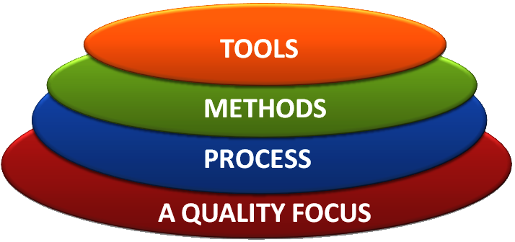

The above four layers of software engineering for our software is described as follows:

* TOOLS:

Our software include frontend and backend which are

developed using the following technologies.

* For frontend :HTML, CSS, Java script .
* For backend: python 3.
* METHODS:

Our software allows the customer to shop online according to their

Convinence and after customer successfully purchase an item the

software automatically generates a digital verifiable bill and sends

the copy of the bill to the customer’s E-mail address.

The software also allows the customer to download the bill in

future also by logging in their respective accounts. The software

also generates a QR code which a customer can keep and on

scanning the QR code the bill will be automatically downloaded to

their system.